Karissa Tatom
7 April 2013
Edu 530-1
Art Methods

Project Title: Geometric Art Grade: 2 Time to Teach: 45 minutes

I find that I can be inspired by almost anything..... The key is to look at all things, even the most common or uninteresting, as a potential source of inspiration. ~Bruce Gray

Integrate:
Math
- Geometric Shapes: Students will examine several shapes and discuss the things that make them similar or different.
- Students will orally identify several shapes with their name, before matching them on the whiteboard

Art History, Bruce Gray:
- Students will understand that Bruce Gray is well known for his abstract artwork. As a child, he was interested in art, but never took any art courses while in high school. He joined the Coast Guard and became more interested in photography. He was initially rejected from art school, before being allowed in and majoring in Design. He traveled all over the country before finally finding his love for paintings and sculpture.
- Students will understand that Gray's work has been featured in many famous photo shoots and movies, including Austin Powers, Gone in 60 Seconds, and Raise Your Voice. He is well known for using circles and other shapes in his artwork.

Standards:

ART

Standard 2: Critical Thinking
Goal 2.1: Conduct analyses in the visual arts.
K. VA. 2.1.1 Identify and respond to characteristics and content of various visual art forms.
K. VA. 2.1.3 Use arts vocabulary to discuss specific works of art.
K.VA.2.1.5 Identify the elements (shape) in art works and environments.
Goal 2.2: Engage in reasoned dialogue and make informed decisions about the visual arts.

Standard 3: Performance
Goal 3.1: Demonstrate skills essential to the visual arts.
K.VA.3.1.1 Acquire and use skills necessary for applying arts techniques, media, and processes. (872.01.b1)
K.VA.3.2.3 Replicate or imitate an existing work, respecting the intent of its original creator. (872.02.b2)
MATH
Standard 4: Concepts and Principles of Geometry
2.M.4.1.1 Recognize, name, build, compare, and sort the two- and three-dimensional shapes of triangles, rectangles, squares, circles, cones, cubes, spheres, cylinders, and pyramids.
2.M.4.1.4 Use appropriate vocabulary. (281.01.d)

Materials:
Construction Paper shapes in a variety of shapes and sizes
Shape print out
Glue sticks
Example Shapes for Whiteboard - 11th bag
Pencils
Pictures of Bruce Gray's artwork, specifically those showcasing his use of geometric shapes

Objectives:
Content (know):
Students will understand that Bruce Gray creates many different kinds of art, focusing on geometric shapes.
Students will understand the terms for shapes and what makes them similar and different.

Language (do):
Students will look at Gray's work and see the shapes that have been discussed.
Students will create an animal out of geometric shapes, writing the number of each shape used, and writing a sentence about their animal.

Vocabulary:
- Abstract: artwork using lines and shapes to show an unlikely result, in this lesson, abstract artwork produced by Gray and animals made out of geometric shapes
- Square: a four sided shape, with the same length sides and right angles
- Rectangle: a four sided shape, with two sides that match and two sides that are different and match, right angles
- Triangle: a three sided shape
- Pentagon: a five sided shape
- Trapezoid: a four sided shape with only two parallel lines, two sides that are the same length
- Parallelogram: a four sided shape with slanted sides, no right angles
- Hexagon: a six sided shape
- Octagon: a eight sided shape

Access Background Knowledge:
Teacher will ask students to tell about their knowledge of shapes with the following questions:
- What shapes have you seen before?
- What makes shapes similar?
- What makes shapes different?
- Can you make artwork out of only shapes?
Teacher will say that famous artists have only used shapes to create amazing artwork.
Teacher will show and then pass out the copies of Bruce Gray's artwork.
- Which painting is your favorite?
- Have you even seen artwork made only out of shapes like these?
- Do you think that these are art even though they only have shapes?

Lesson:
History:
Teacher will explain Bruce Gray's biography and explain that his artwork is considered abstract, explaining what this means.

Math:
Teacher will show students the different shapes, asking them what makes them similar and different.
Teacher will ask students to match the shape's definition with its picture on the whiteboard.
The teacher will encourage students to match what they see on the board with their shapes, holding up a shape when the definition is read.
Teacher will assess the student comprehension by asking individual students to orally name the shape, and by looking around the classroom as students hold up their shapes, checking for understanding and correcting any misunderstandings as they occur.

Art:
Teacher will distribute art supplies: shape page, shapes, and glue.
Teacher will ask students to choose an animal to create based on the provided examples.
Teacher will give students time to create their animals, circulating the room, and helping as needed.
The teacher will point out the various parts of the handout, including creating the animal, counting the shapes, and writing a sentence about their animal.
The teacher will model how to create the animal, with the example of the mouse.
Teacher will encourage students to create additional animals as time allows.
Teacher will encourage students to use the vocabulary words as applicable throughout the lesson.
Teacher and students will clean up the art supplies, handing in the shapes handout when finished.

Sum Up:
Teacher will ask students to share their shape animal, reading the number of shapes and the sentence they wrote.
Teacher will ask students to identify various shapes they see in each other's work.

Assessment:
Students will be assessed throughout the lesson based upon their oral answers to questions, their artwork they create, and their ability to count the shapes in their animal and write a sentence about their animal.
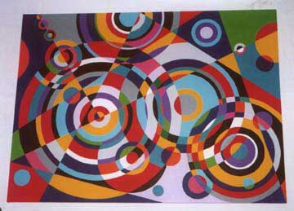

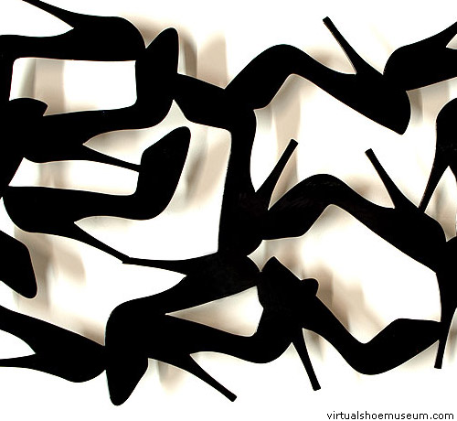

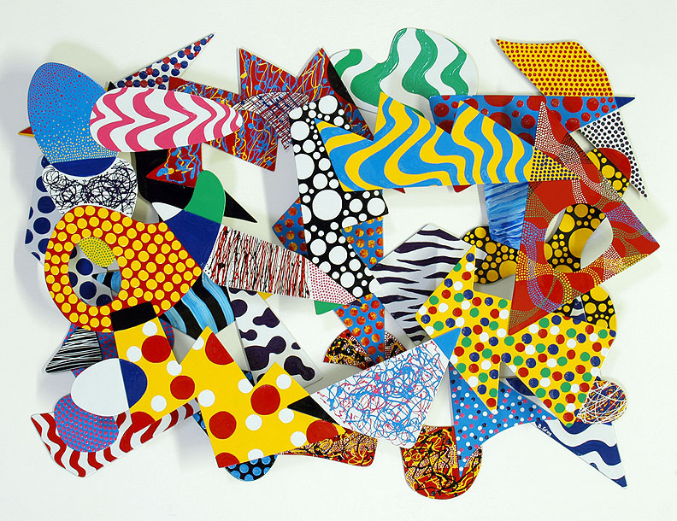

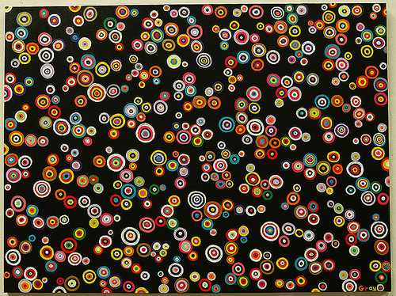

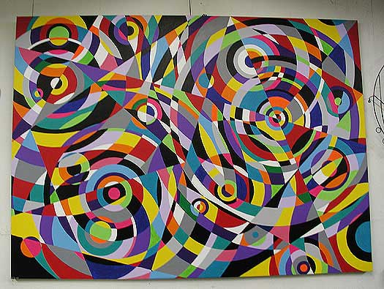

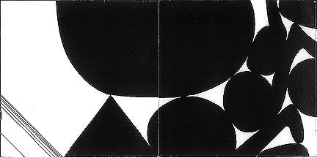

This is a special blue jay. I made the blue jay with shapes and it
has long legs. It lays eggs and it eats worms. It has a long beak.

My animal is called a duck. It eats bread, lives in water, swims a lot and quacks all day everyday. My duck has feathers too.

Shape Animal Name: ______________________________

The animal I made is a: __________________________________________________
I used ______________________________ trapezoids
I used ______________________________ circles
I used ______________________________ rectangles
I used ______________________________ squares
I used ______________________________ triangles
I used ______________________________ parallelograms
I used ______________________________ hexagons
I used ______________________________ octagons
I used ______________________________ pentagons
My sentence about my animal:
__________________________________________________________________
__________________________________________________________________
__________________________________________________________________
__________________________________________________________________

